#program for Fibonacci sequence using recursion

Program:

package oopslab_java;

import java.util.Scanner;

public class Fibonacci {

public static int fibo(int n) { //static method ,it can be accessed before object creation

if(n<=0) {

return 0;

}

else if (n==1) {

return 1;

}

else {

return *fibo*(n-1) + *fibo*(n-2);

}

}

public static void main(String args[]) {

Scanner scanner = new Scanner(System.***in***);

System.***out***.println("Enter the number of terms(n) : ");

int n= scanner.nextInt();

System.***out***.println("Fibonacci series");

for(int i=0;i<n;i++) {

System.***out***.print(*fibo*(i)+ " ");

}

scanner.close();

}

}

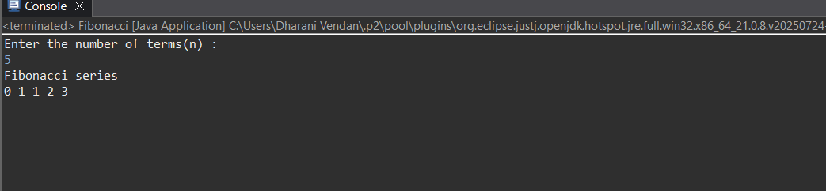output:



